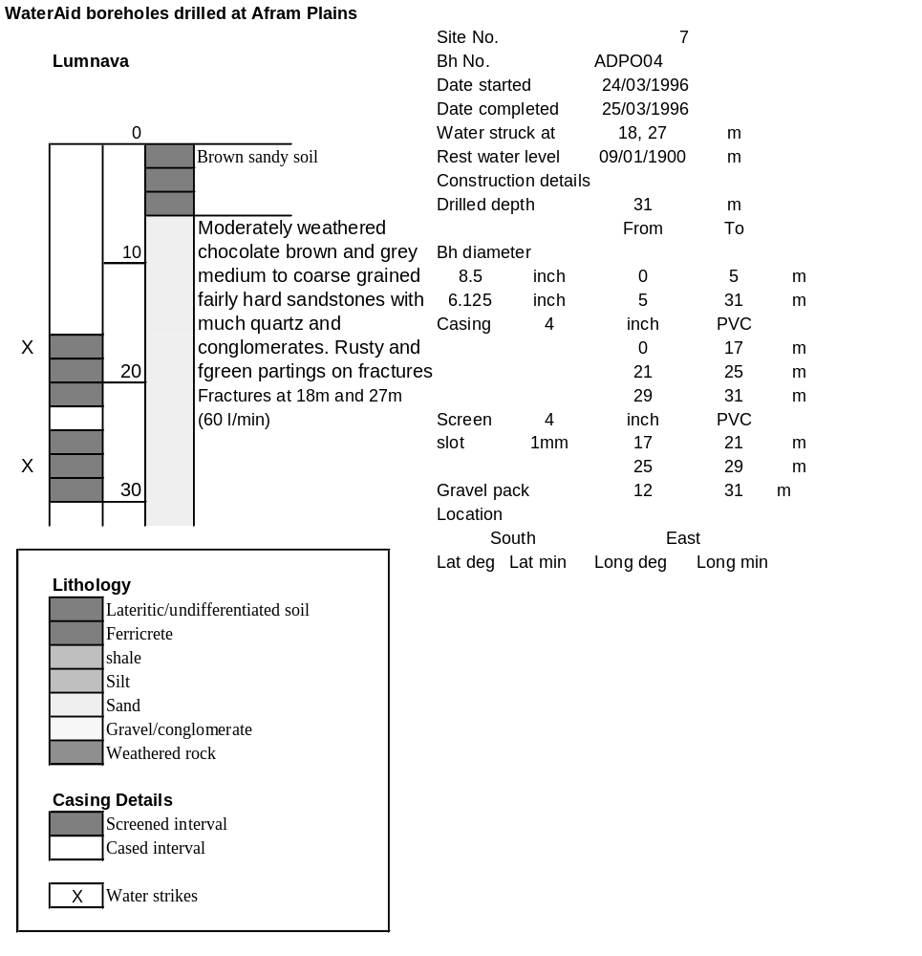

Ghana | Test pumping
Borehole No. |  | APDO4
Hole No |  | 7
Village |  | Lumnava
Date |  | 14/04/1996
Point above GL |  | 0.5 | m
Pump depth |  | 30 | m
SWL |  | 9.76 | m
Start Time |  | 08:00
Drawdown test |  |  |  |  | Recovery test
time | pwl (m) | Q l/min | dd | sc | Time | wl (m) | s' | t/t'
0.00 | 9.76 | 25.00 | 0.00 |  | 0.00 | 13.19 | 3.43
1.00 | 10.37 | 25.00 | 0.61 | 40.98 | 1.00 | 11.07 | 1.31 | 181.00
2.00 | 10.47 | 25.00 | 0.71 | 35.21 | 2.00 | 10.68 | 0.92 | 91.00
3.00 | 10.48 | 25.00 | 0.72 | 34.72 | 3.00 | 10.49 | 0.73 | 61.00
4.00 | 10.55 | 25.00 | 0.79 | 31.65 | 4.00 | 10.38 | 0.62 | 46.00
5.00 | 10.60 | 25.00 | 0.84 | 29.76 | 5.00 | 10.31 | 0.55 | 37.00
6.00 | 10.65 | 25.00 | 0.89 | 28.09 | 6.00 | 10.26 | 0.50 | 31.00
7.00 | 10.69 | 25.00 | 0.93 | 26.88 | 7.00 | 10.22 | 0.46 | 26.71
8.00 | 10.68 | 25.00 | 0.92 | 27.17 | 8.00 | 10.19 | 0.43 | 23.50
9.00 | 10.68 | 25.00 | 0.92 | 27.17 | 9.00 | 10.16 | 0.40 | 21.00
10.00 | 10.84 | 35.00 | 1.08 | 32.41 | 10.00 | 10.14 | 0.38 | 19.00
11.00 | 10.87 | 35.00 | 1.11 | 31.53 | 12.00 | 10.11 | 0.35 | 16.00
12.00 | 10.98 | 35.00 | 1.22 | 28.69 | 14.00 | 10.09 | 0.33 | 13.86
13.00 | 11.00 | 35.00 | 1.24 | 28.23 | 16.00 | 10.07 | 0.31 | 12.25
14.00 | 11.10 | 35.00 | 1.34 | 26.12 | 18.00 | 10.05 | 0.29 | 11.00
15.00 | 11.11 | 35.00 | 1.35 | 25.93 | 20.00 | 10.04 | 0.28 | 10.00
16.00 | 11.24 | 35.00 | 1.48 | 23.65 | 22.00 | 10.03 | 0.27 | 9.18
17.00 | 11.34 | 35.00 | 1.58 | 22.15 | 24.00 | 10.02 | 0.26 | 8.50
18.00 | 11.36 | 35.00 | 1.60 | 21.88 | 26.00 | 10.01 | 0.25 | 7.92
19.00 | 11.50 | 35.00 | 1.74 | 20.11 | 28.00 | 10.00 | 0.24 | 7.43
20.00 | 11.77 | 35.00 | 2.01 | 17.41 | 30.00 | 9.99 | 0.23 | 7.00
22.00 | 12.28 | 35.00 | 2.52 | 13.89 | 35.00 | 9.97 | 0.21 | 6.14
24.00 | 12.44 | 35.00 | 2.68 | 13.06 | 40.00 | 9.96 | 0.20 | 5.50
26.00 | 12.54 | 35.00 | 2.78 | 12.59 | 45.00 | 9.95 | 0.19 | 5.00
28.00 | 12.60 | 35.00 | 2.84 | 12.32 | 50.00 | 9.94 | 0.18 | 4.60
30.00 | 12.64 | 35.00 | 2.88 | 12.15 | 60.00 | 9.93 | 0.17 | 4.00
35.00 | 12.73 | 35.00 | 2.97 | 11.78 | 70.00 | 9.92 | 0.16 | 3.57
40.00 | 12.78 | 35.00 | 3.02 | 11.59 | 80.00 | 9.91 | 0.15 | 3.25
45.00 | 12.84 | 35.00 | 3.08 | 11.36 | 90.00 | 9.89 | 0.13 | 3.00
50.00 | 12.85 | 35.00 | 3.09 | 11.33 | 100.00 | 9.88 | 0.12 | 2.80
55.00 | 12.88 | 35.00 | 3.12 | 11.22 | 110.00 | 9.87 | 0.11 | 2.64
60.00 | 12.92 | 35.00 | 3.16 | 11.08 | 120.00 | 9.86 | 0.10 | 2.50
70.00 | 12.96 | 35.00 | 3.20 | 10.94
80.00 | 13.00 | 35.00 | 3.24 | 10.80
90.00 | 13.00 | 35.00 | 3.24 | 10.80
100.00 | 13.03 | 35.00 | 3.27 | 10.70
110.00 | 13.04 | 35.00 | 3.28 | 10.67
120.00 | 13.09 | 35.00 | 3.33 | 10.51
130.00 | 13.08 | 35.00 | 3.32 | 10.54
140.00 | 13.10 | 35.00 | 3.34 | 10.48
160.00 | 13.17 | 35.00 | 3.41 | 10.26
180.00 | 13.19 | 35.00 | 3.43 | 10.20

